File permissions in Linux

Project description

My organization's research team needs me to modify the access rights for specific files and folders within the projects directory. The current permissions do not match the intended authorization levels, posing a potential security risk. Auditing and rectifying these permissions will enhance the system's security posture. To address this concern, I undertook the following steps:

Check file and directory details

The following code demonstrates how I used Linux commands to determine the existing permissions set for a specific directory.

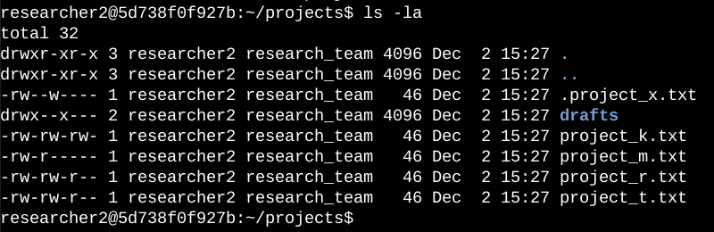

The first line displays the command ls -la to display a detailed listing of the file contents that also includes hidden files. The output also indicates that there is one directory named drafts and on hidden file named .project_x.txt. the 10 character string in the first column represents the permissions set on each file.

Change file permissions

The organization determined that other shouldn’t have write access to any of their files. To comply with this, I referred to the file permissions that I previously returned and that project_k.txt must have the write access removed for other.

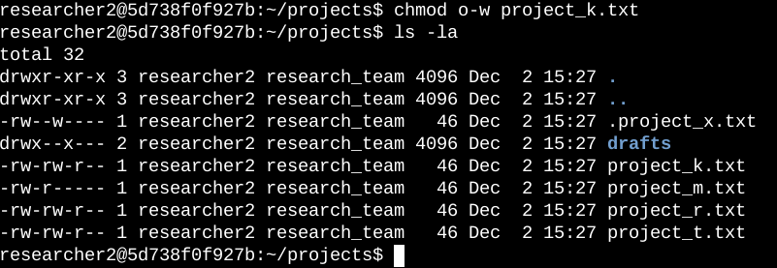

The first two lines display the command chmod o-w project_k.txt and ls -la to confirm the change. The chmod command changes the permission on the files and directories.

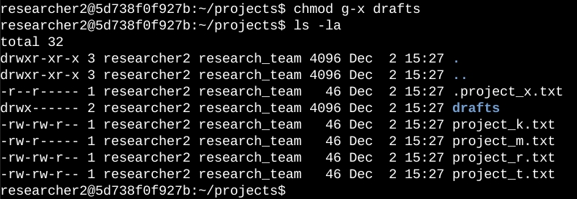

In this screenshot displays the commands that I entered. The first line input uses chmod to change the group permission to remove execute permissions in the drafts directory.

Summary

I changed multiple permissions to match the level of authorization my organization wanted for files and directories in the project’s directory. The first step in this was using ls -la to check the permissions for the directory. This informed my decisions in the following steps. I then used the chmod command multiple times to change the permissions on files and directories.